Joseph Woodside

CIS311
4/26

How to Connect to a Wi-Fi Network (Windows PC)
These instructions explain how to connect a Windows computer to a Wi-Fi network. This process allows your device to access the internet wirelessly.
Requirements
- A Windows computer
- A working Wi-Fi network
- The Wi-Fi network name (SSID)
- The Wi-Fi password (security key)
Important
- Make sure Wi-Fi is turned on
- Ensure you are within range of the network

Step-by-Step Instructions
Step 1: Turn On Wi-Fi
- Click the Wi-Fi icon in the bottom-right corner of your screen.
- Make sure Wi-Fi is turned on.

Step 2: View Available Networks
- Click the Wi-Fi icon again.
- A list of available networks will appear.

Step 3: Select Your Network
- Find your network name (SSID).
- Click on it.
- Click Connect.

Step 4: Enter the Password
- Type the Wi-Fi password carefully.
- Click Next.

Step 5: Confirm Connection
- Wait a few seconds.
- Look for the message “Connected, secured.”

Technical Terms
- SSID: The name of your Wi-Fi network.
- Wi-Fi Password: A security key used to access the network.
- Network Adapter: Hardware that allows your computer to connect to Wi-Fi.
Troubleshooting
- If the password is incorrect, re-enter it carefully.
- If the network does not appear, move closer to the router.
- If the connection fails, restart your computer and try again.
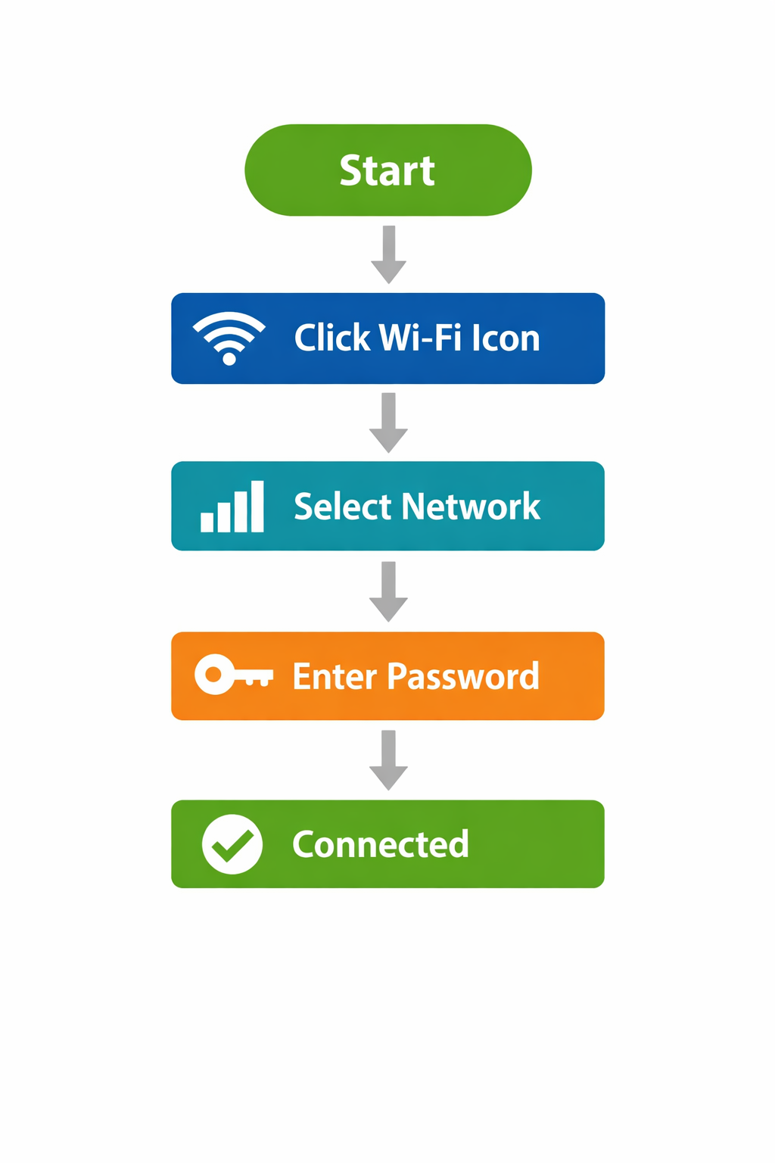
Visual Aid
Troubleshooting
- If the password is incorrect, re-enter it carefully.
- If the network does not appear, move closer to the router.
- If the connection fails, restart your computer and try again.
Reflection
After testing these instructions with a classmate, I found that a few areas needed improvement. Initially, the instructions did not clearly explain what “SSID” meant, which caused confusion. I added a definition in the technical terms section to clarify this. I also noticed that the tester hesitated during the connection confirmation step, so I revised the instructions to include the exact message “Connected, secured” to make it clearer what to look for.
Another improvement I made was adding troubleshooting tips. During testing, the user entered the wrong password and did not know what to do next. By including common issues and solutions, the instructions became more user-friendly and reduced frustration.
Testing the instructions helped me understand how important it is to write from the user’s perspective. Even simple steps can be unclear if not explained properly. I learned that effective technical writing requires clear language, logical organization, and anticipating possible user errors. Including visuals, definitions, and troubleshooting steps greatly improves the usability and clarity of instructions (Kolin, 2022).

References
Kolin, P. C. (2022). Successful writing at work (12th ed.). Cengage.

